Dragon Boat Ornament

Materials:
- Cardboard form
- Crochet thread, embroidery floss, yarn, etc.
- Scotch tape
- Glue
- Dental butler or tapestry needle, for finishing off the thread
- Scissors
- Bubble-headed pins (optional)
- Beads for tail (optional)
Cardboard form can be made from an empty cereal box. Here is the pattern:

Loop
2
1
1
1
2
2

Tassel tail

The squares can be any size you like. For our project, our squares are 2”x2”, but I’ve found that 1½“x1½” is also a good size. Hint: score the lines on the cardboard form for easy folding.

Steps:
- Bend the cardboard form along the lines.
- Make a loop for the top of the ornament. On the wrong side of the cardboard, tape the loop opposite the double 2’s so that it hangs above the cardboard.
- Make a tassel or string some beads on a thread to make a tail. On the wrong side of the cardboard form, tape the tail opposite the double 1’s so that it hangs below the cardboard.
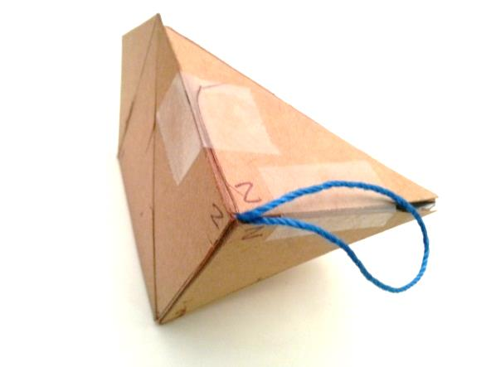
- Bend the form so that all three 2’s meet at the loop. Secure the edges with tape.
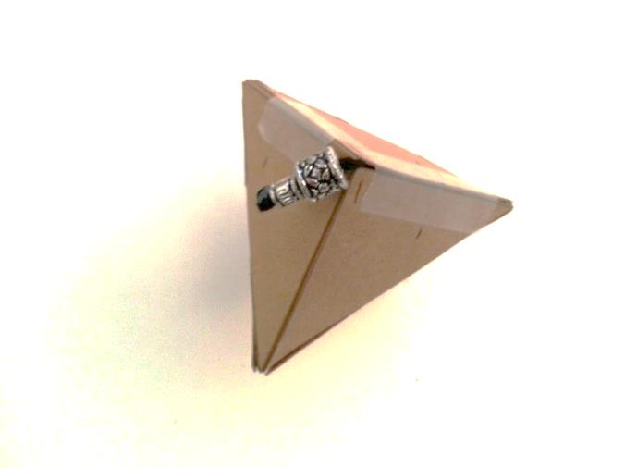
- Bend the form so that all three 1’s meet at the tail. Secure the edges with tape.
- Tuck in the tab and secure with tape.
- Insert bubble-headed pins in each of the 3 empty corners.
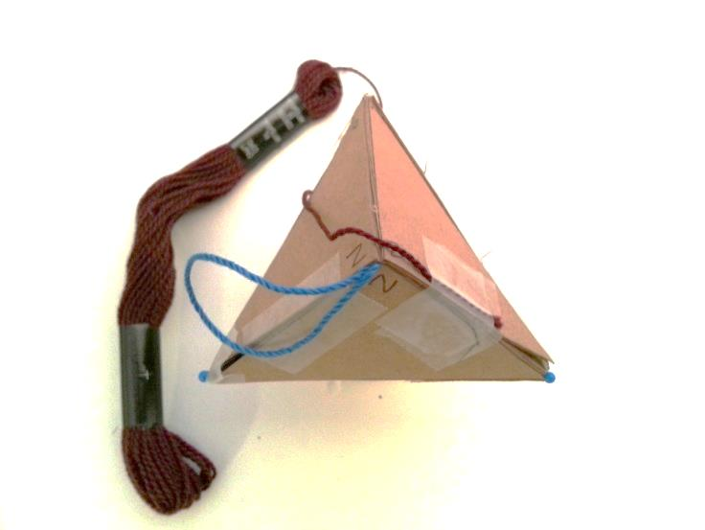
- Lay the end of the floss along one of the edges near a ‘2’ and tape it down. It should be positioned so that the short end projects down away from the loop.
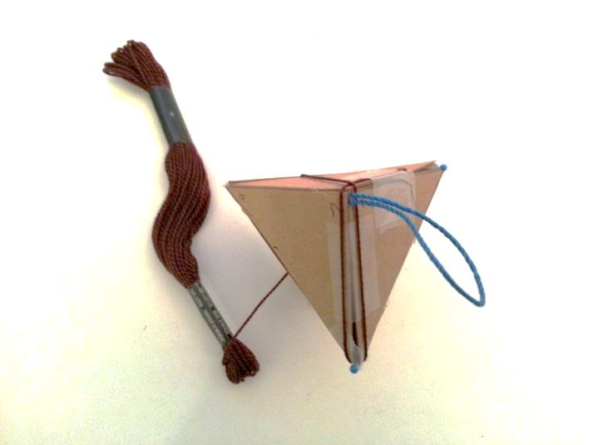
- Wind the floss around the loop at the top and down the next adjacent edge.
- Wind the floss around the bubble-headed pin and back up to the loop at the top.
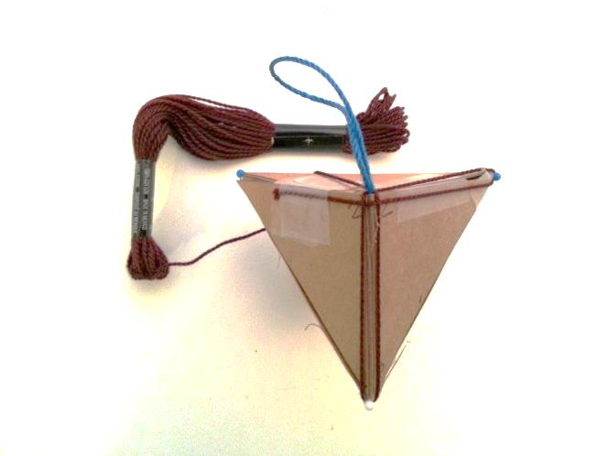
- Continue winding the floss in the same manner: down the next adjacent edge, around the bubble-headed pin, up other side, etc.
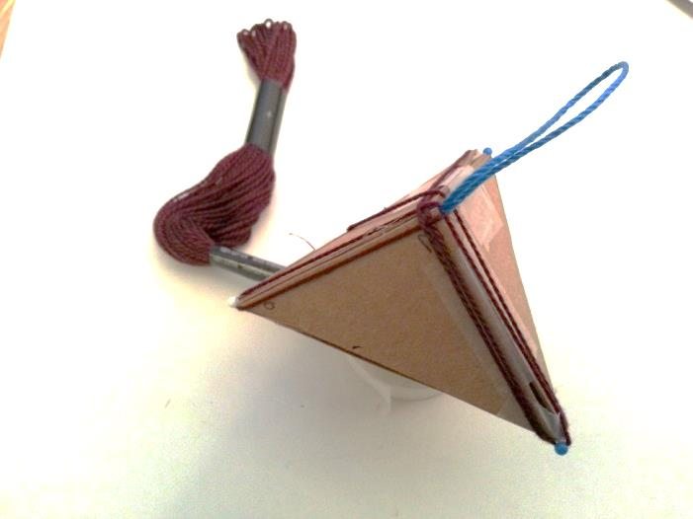
- When you get to your starting point, continue winding in the same pattern, laying the floss down next to the strand on that edge.
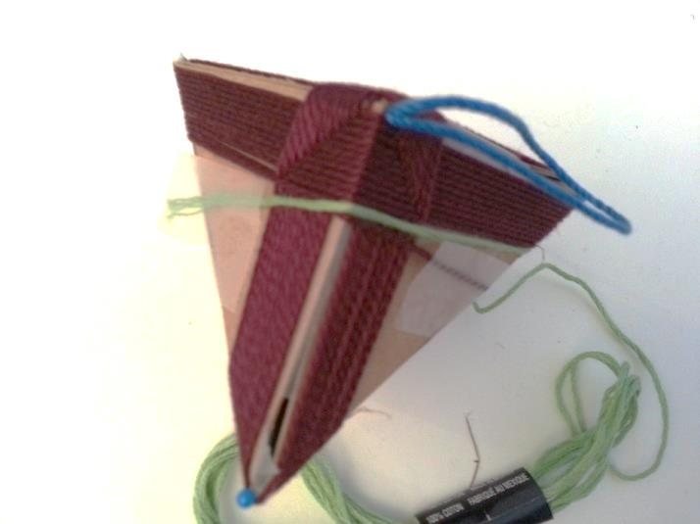
- To change flosses, cut off the old floss (if necessary) and tape it down on one of the cardboard faces. Tape down the new floss on a preceding cardboard face. Continue winding with the new floss.
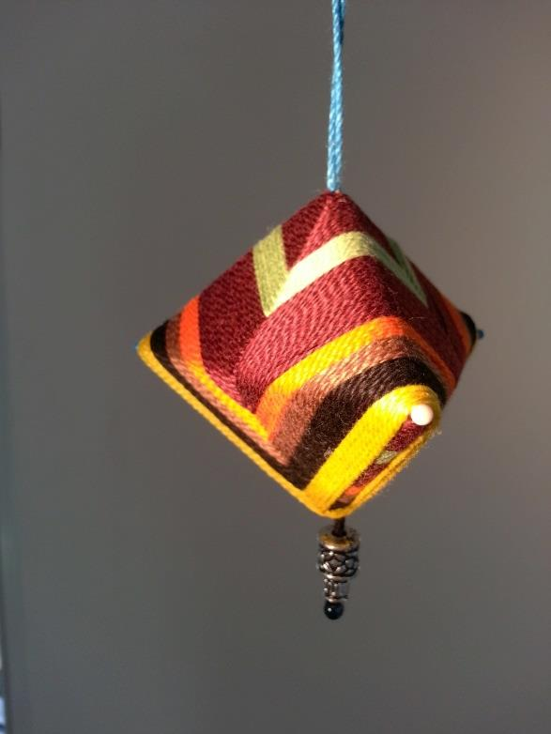
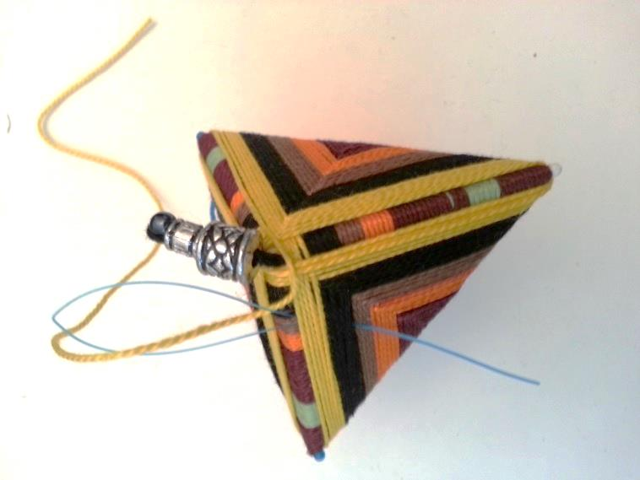
- To finish the ornament, put a dab of glue on the bottom tip and lay the end of the floss over it. Hold it down for a minute to secure that it sticks.
- Cut the end of the floss so you have about 4 inches left. Thread the floss into a tapestry needle or dental butler and loop it underneath the strands of floss on the ornament and trim the end, so it doesn’t show.

